Report of Third Project

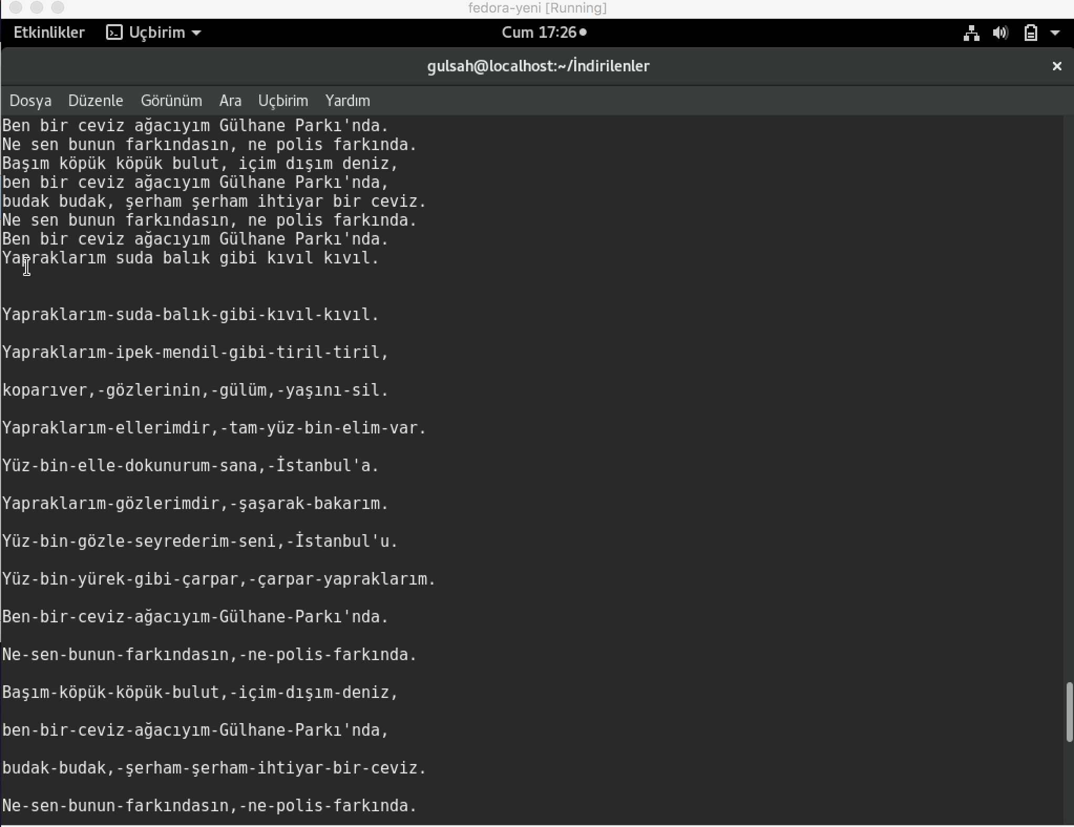
Aim of this project is to create 4 threads which are for reading a text file that is entered from an user , for changing blanks with “-” in this text , for making upper letter from lower letter and writing all updates in this file to a text file is called “log txt” according to thing we mentioned. To achieve this situtaion , binary semaphores ,”kuyruk.h” header and queues are used to synchronize threads .

first it will go to linebyline and write log and stout second it will go to upper and replacer.
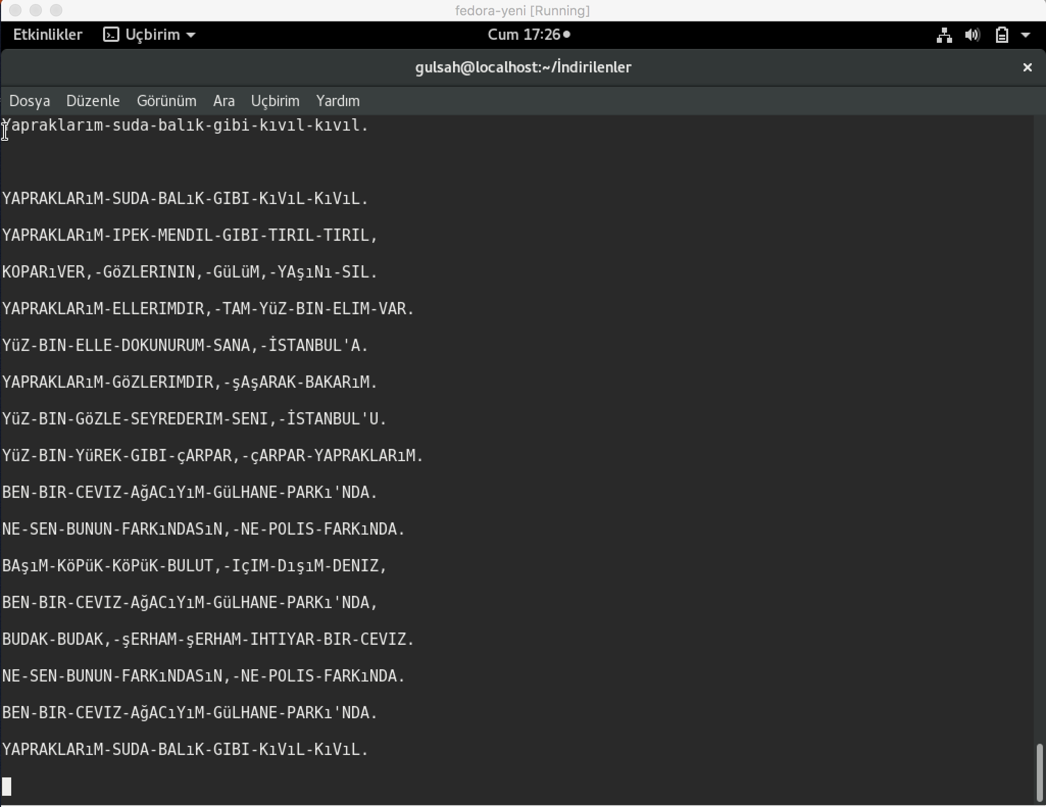
And the wery last step it will go to writer thread.

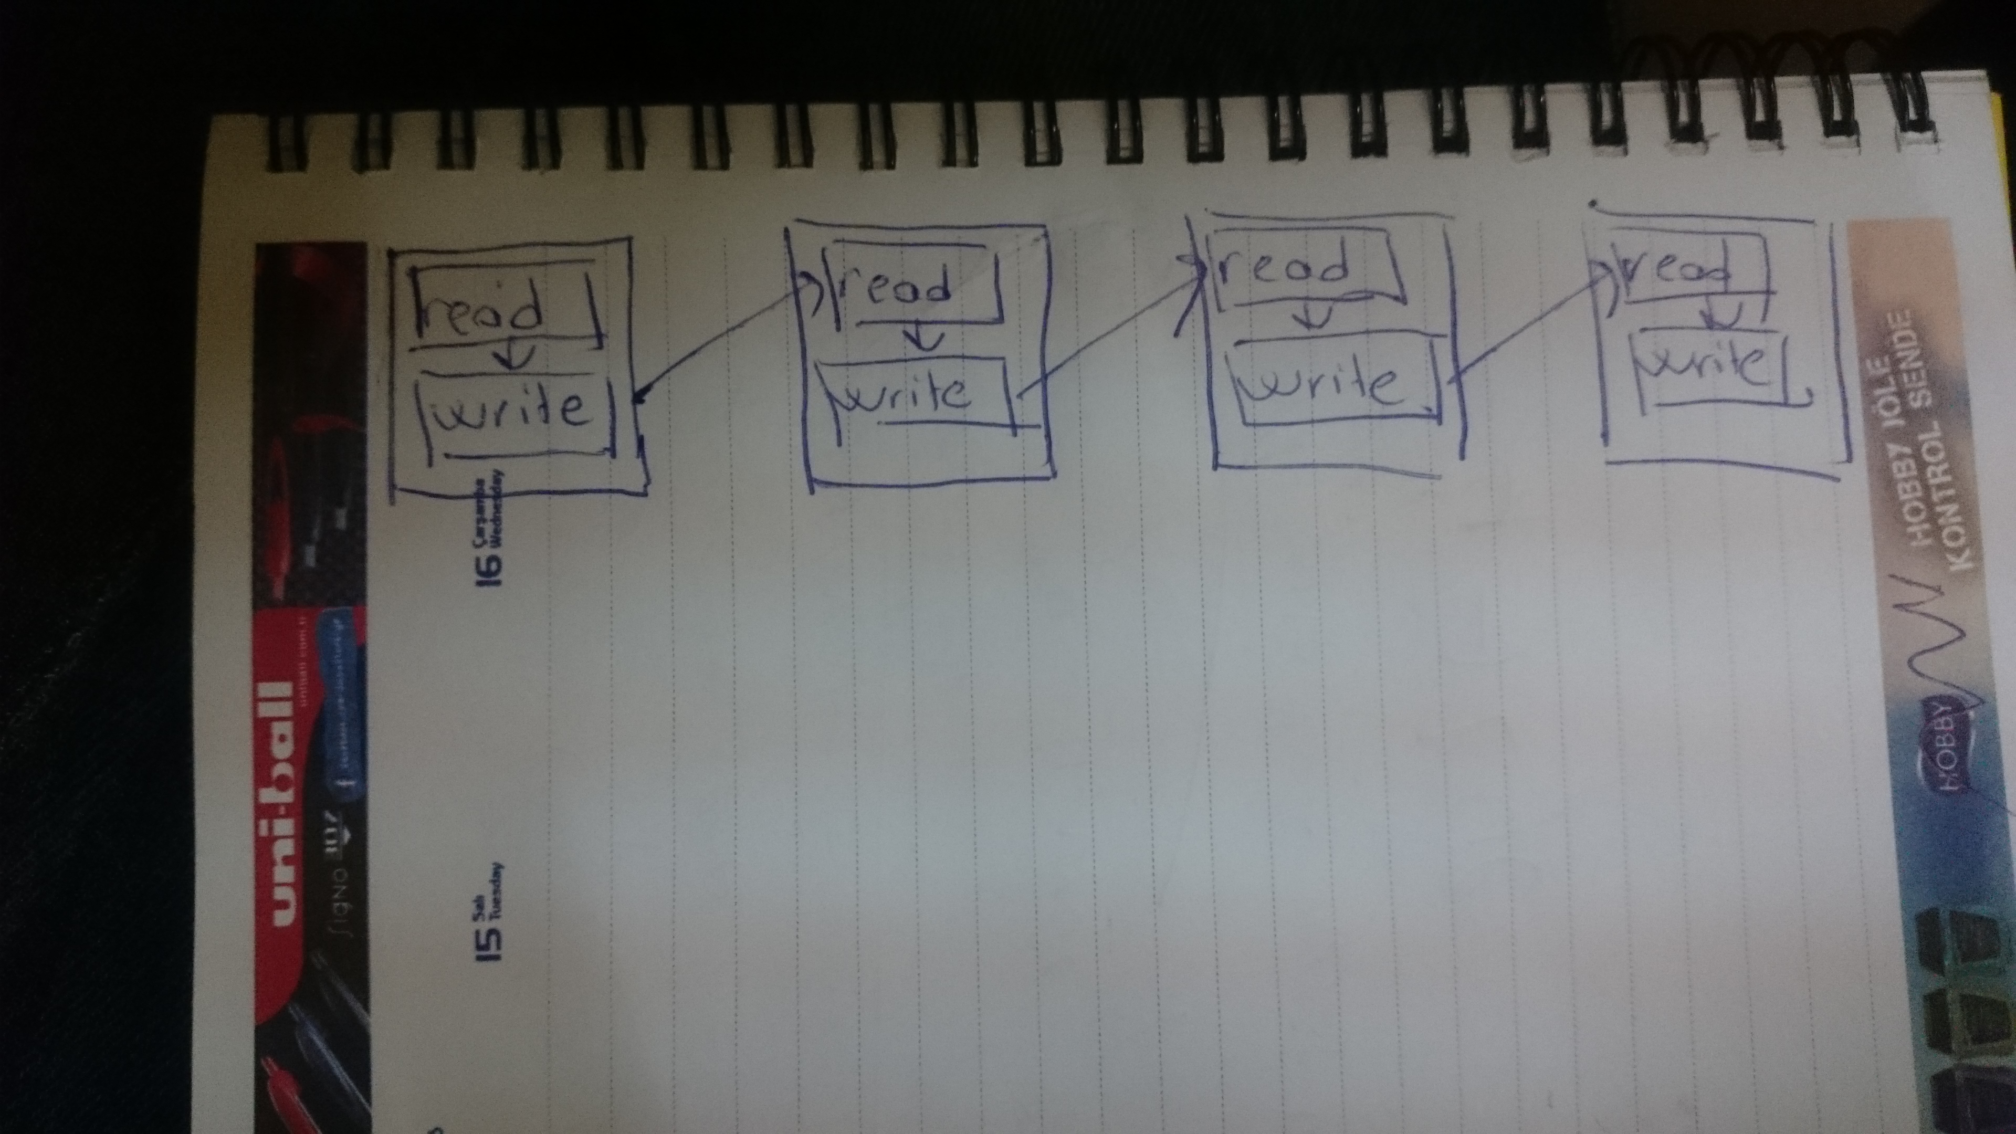

Sezin Gümüş
Gülşah Yılmaz

